Prime Throughput Performance Evaluation
Report 3

Source Code and GitHub Repositories
The files used for this evaluation can be found at the following repository: https://github.com/sam444555/cs2910
The original Prime code used is available at the following Johns Hopkins DSN repository:
https://github.com/jhu-dsn/prime

Revised Latency Measurement Methodology
The approach to latency measurement has been modified since the last report. Previously, the timer used to measure the latency of an arbitrary update n did not start until the update had been successfully sent in the Send_Update(…) function. This approach failed to accurately capture the back pressure experienced by some updates while waiting to be sent to Prime daemon, resulting in a misrepresentation of actual end-to-end latency.
Under the revised approach, once a sending stall is encountered, the update’s latency timer will begin. Room exists in the network pipeline (num_outstanding_updates < num_clients_to_emulate); therefore, the update should be inserted and its latency timer started regardless of whether it can be sent immediately to the Prime daemon. This incorporates the back pressure-induced delay into the latency measurement, resulting in a more accurate latency representation experienced by each update. This applies to all updates in the current function invocation (n, n+1, n+2….) until the entire network pipeline becomes full or no updates remain to be sent.
Send_Update function modifications
The Send_Update(…) function was modified to support the revised approach. The primary change is that the main loop continues whenever a stall is encountered instead of returning immediately. Once detected, num_outstanding_updates and curr_seq_num at the current iteration are recorded for rollback purposes & every subsequent send starts the latency timer for the current sequence number without creating and sending an actual update.
Once the loop exits, the rollback is applied and undoes the changes made to the aforementioned variables so follow up function invocations can correctly attempt to resend the stalled updates. A socket event handler was also added to monitor availability and send a subsequent Send_Update(…) once the socket became writable. This handler gets added outside the main loop body only if a sending stall was detected (indicated by stall_detected flag) otherwise it is detached to prevent unnecessary calls.
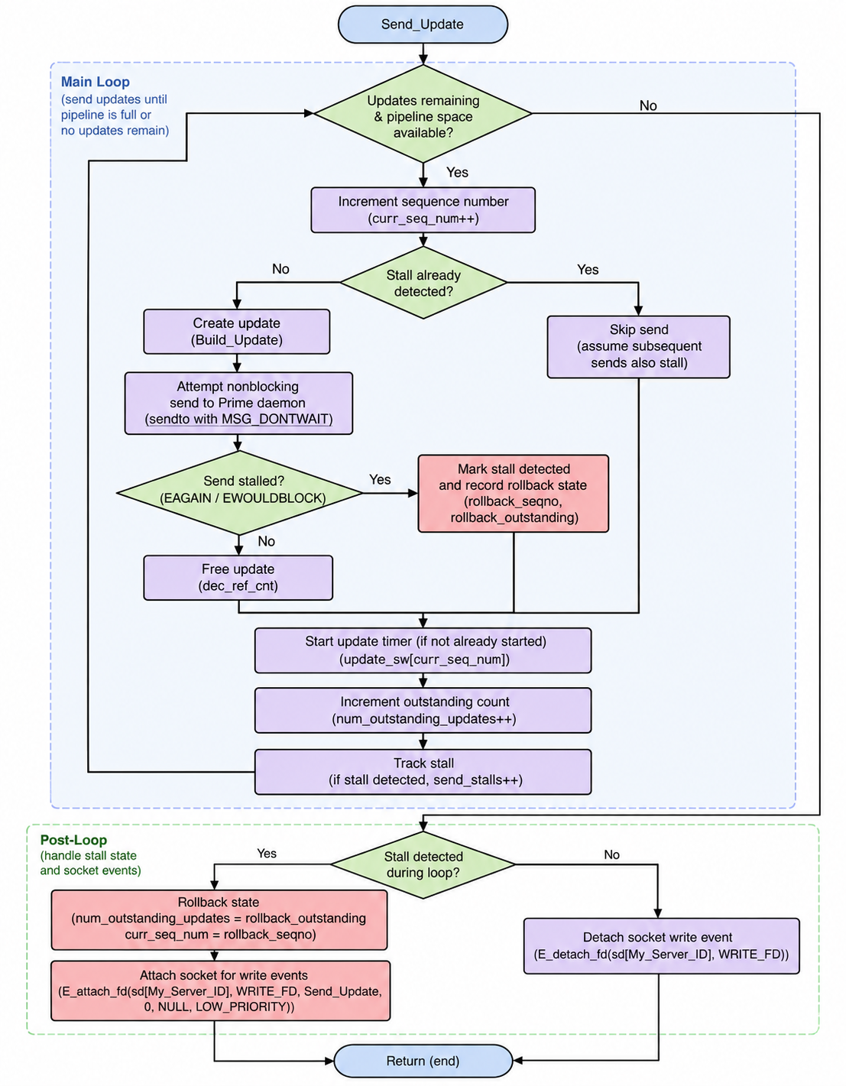
Figure 1. Send_Update function logic flowchart

Sending Freeze Resolved
These changes resolved the occasional freezing behavior that had previously affected the driver program. I have since been unable to reproduce this issue even under the most demanding test conditions (100,000 total updates and 150 emulated clients).
The root of the client-side sending issues can be traced back to Prime itself, specifically the MAX_PO_IN_FLIGHT configuration parameter located in prime/src/def.h. Once MAX_PO_IN_FLIGHT has been reached or exceeded, Prime detaches the client socket from READ_FD (PRE_ORDER_Send_PO_Request(…) located in prime/src/pre_order.c), temporarily preventing additional client requests until more capacity becomes available. It reattaches in prime/src/order.c when the difference between the most recently created PO sequence and the most recently executed PO sequence is exactly equal to MAX_PO_IN_FLIGHT.

I suspected the issue was Prime failing to reattach the client socket. To investigate this theory, I ran 25 driver tests using the following input:
- Number of emulated clients = 50
- Total Updates = 20k
- MAX_PO_IN_FLIGHT = 20 (default value)
- No bandwidth limitation
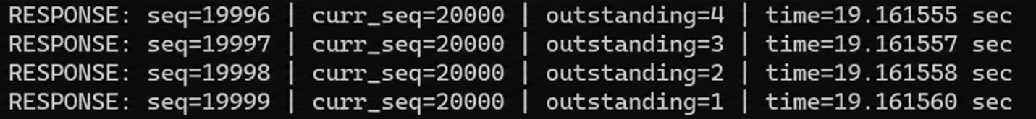
- Single driver running on prime1
I continuously observed that the program would freeze when there was 1 outstanding update remaining (19,999/20,000 successfully processed). I encountered the same failure conditions again, this time with the Prime daemon logging its socket attach and detach operations.
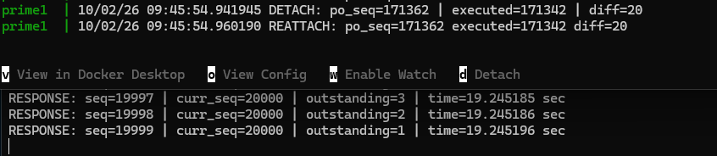

Therefore, the results of the experiments indicate that Prime’s attach/detach behavior is likely not the culprit. Some notable observations from running these experiments (as well as other testing):
- No clear failure pattern
  - Can not appear for dozens of tests and then appear unexpectedly
- Occurs more frequently with higher number of emulated clients
- With most recent driver modifications, only happening with the final update
Theory:
- Driver is not stuck waiting to resend the packet (the WRITE_FD even listener addresses this)
- Driver THINKS it has successfully sent the final packet
  - Otherwise, the output would result in an inf loop of resend attempts instead of freezing
- Driver “thinks” it has successfully delivered the final packet Prime receives the packet
  - Its not a delivery issue due to the socket attach/detach behavior
- For whatever reason, Prime fails to order/execute the final update and return a response to the driver
- This behavior was observed only with the default MAX_PO_IN_FLIGHT
- Next step: Trace Prime’s handling of the final packet when this behavior occurs

MAX_PO_IN_FLIGHT Testing
Single Driver Configuration (250 Mbps link speed, 25k total sends, MAX_PO_IN_FLIGHT=20)
 |  | Throughput (updates/sec) |  | Latency (ms)
Num. Emulated Clients | Elapsed Time (seconds) | Expected | Actual | Min | Max | Avg
25 | 24.15 | 1038.91 | 1035.24 | 17.08 | 45.318 | 24.064
50 | 24.21 | 1036.6 | 1032.76 | 24.572 | 77.56 | 48.234
75 | 24.36 | 1029.83 | 1026.37 | 16.938 | 99.882 | 72.827
100 | 24.43 | 1026.78 | 1023.39 | 24.385 | 137.508 | 97.392
200 | 24.3 | 1033.9 | 1028.7 | 20.202 | 220.201 | 193.443
Single Driver Configuration (250 Mbps link speed, 25k total sends, MAX_PO_IN_FLIGHT=75)
 |  | Throughput (updates/sec) |  | Latency (ms)
Num. Emulated Clients | Elapsed Time (seconds) | Expected | Actual | Min | Max | Avg
25 | 20.88 | 1201.63 | 1197.21 | 17.48 | 43.516 | 20.805
50 | 19.64 | 1276.79 | 1273.01 | 19.469 | 55.103 | 39.161
75 | 13.4 | 1872.51 | 1865.03 | 19.204 | 50.224 | 40.053
100 | 13.26 | 1892.68 | 1885.39 | 20.578 | 92.562 | 52.835
200 | 13.25 | 1895.55 | 1886.82 | 27.421 | 131.899 | 105.511

